**CURSORS.**

**Scenario 1:** Generate monthly statements for all customers.

* + Question: Write a PL/SQL block using an explicit cursor GenerateMonthlyStatements that retrieves all transactions for the current month and prints a statement for each customer.

**SOLUTION:**

**Query:**

declare

cursor GenerateMonthlyStatements is select transactionid,accountid,transactiondate,amount from transactions where trunc(transactiondate,'MM')=trunc(sysdate,'MM');

t_transid transactions.transactionid%type;

t_accid transactions.accountid%type;

t_date transactions.transactiondate%type;

t_amo transactions.amount%type;

begin

    open GenerateMonthlyStatements;

    loop

        fetch GenerateMonthlyStatements into t_transid,t_accid,t_date,t_amo;

        exit when GenerateMonthlyStatements%NOTFOUND;

        dbms_output.put_line('MONTHLY STATEMENT OF CUSTOMER WITH ACCOUNTID: '||t_accid);

        dbms_output.put_line('TRANSACTIONID: '||t_transid);

        dbms_output.put_line('TRANSACTIONDATE: '||t_date);

        dbms_output.put_line('AMOUNT: '||t_amo);

    end loop;

    close GenerateMonthlyStatements;

end;

**Output:**

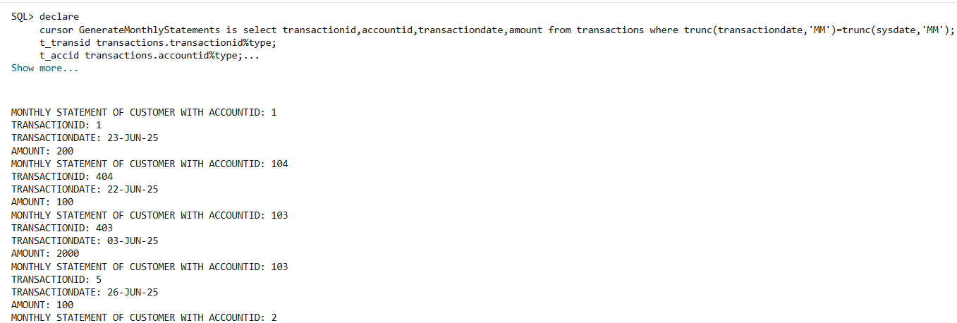

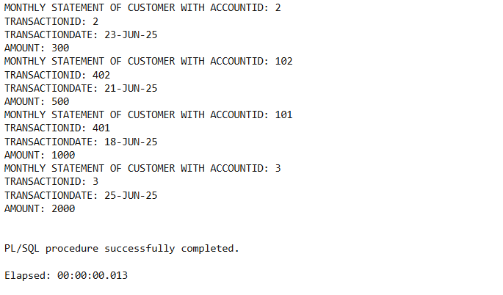

**Scenario 2:** Apply annual fee to all accounts.

* + Question: Write a PL/SQL block using an explicit cursor ApplyAnnualFee that deducts an annual maintenance fee from the balance of all accounts.

**SOLUTION:**

Query: select accountid,balance from accounts;

Output:

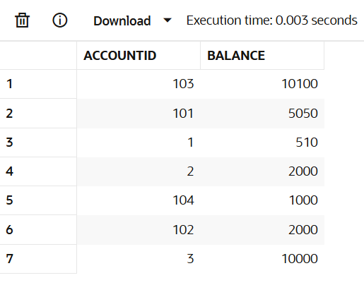

**Query:**

declare

cursor ApplyAnnualFee is select accountid from accounts;

a_id accounts.accountid%type;

annual_maintain_fee number:=100;

begin

    open ApplyAnnualFee;

    loop

        fetch ApplyAnnualFee into a_id;

        exit when ApplyAnnualFee%NOTFOUND;

        update accounts set balance=balance-annual_maintain_fee where accountid=a_id;

    end loop;

    close ApplyAnnualFee;

end;

**Output:**

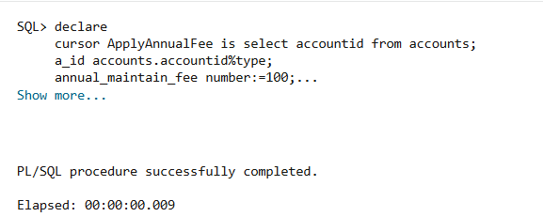

**Query:** select accountid,balance from accounts;

**Output:**

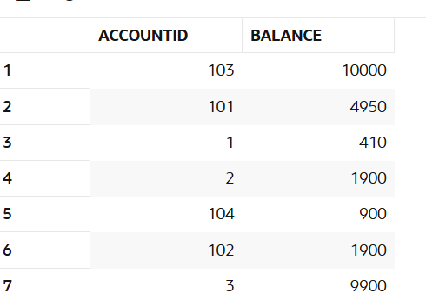

**Scenario 3:** Update the interest rate for all loans based on a new policy.

* + Question: Write a PL/SQL block using an explicit cursor UpdateLoanInterestRates that fetches all loans and updates their interest rates based on the new policy.

**SOLUTION:**

**Query:** select loanid,loanamount,interestrate from loans;

**Output:**

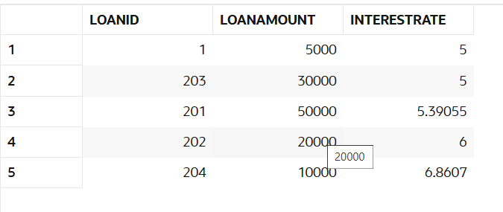

**Query:**

declare

cursor UpdateLoanInterestRates is select loanid,loanamount,interestrate from loans;

l_rate loans.interestrate%type;

l_amount loans.loanamount%type;

l_id loans.loanid%type;

begin

    open UpdateLoanInterestRates;

    loop

        fetch UpdateLoanInterestRates into l_id,l_amount,l_rate;

        exit when UpdateLoanInterestRates%NOTFOUND;

        if l_amount>10000 then

        update loans set interestrate=interestrate-1 where loanid=l_id;

        end if;

    end loop;

    close UpdateLoanInterestRates;

end;

**Output:**

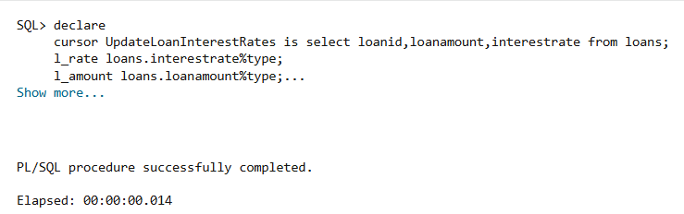

**Query:** select loanid,loanamount,interestrate from loans;

**Output:**

